iPhone - Video Ad Campaign – 13 Dec 2025
iPhone - Ad Campaign - 13 Dec 2025
Timeline: 15 Days
Budget: ₹75,000
Goal: Create an impressive, high-impact video ad focused on product features, with a compelling first 5 seconds to drive website visits and audience retention.
1. Competitor Analysis – Indian Smartphone Market
Key Competitors of iPhone (Premium Segment in India)
1. Samsung Galaxy S Series (e.g., S23 Ultra / S24 Series)
- Strong brand presence in premium Android category
- Known for high-end camera zoom capabilities
- Competes directly with iPhone in pricing and features
2. Google Pixel Series (Pixel 7 Pro / Pixel 8 Pro)
- Known for computational photography
- Clean Android OS with seamless Google integration
- Strong presence among creators and photography lovers
3. OnePlus (OnePlus 12 / 11 / OnePlus Open)
- Competitive pricing with flagship-level specs
- Popular among performance-focused users
- Strong brand recall for speed and user experience
2. Unique Selling Propositions (USPs) of iPhone 14 Pro
USP 1: Dynamic Island – A New Interaction Experience
A unique interface that shows alerts, activities, calls, navigation, and music in a fluid, interactive way—exclusive to iPhone.
USP 2: 48MP Pro Camera System with Photonic Engine
Delivers industry-leading low-light performance and cinematic-quality videos; ideal for creators and professionals.
USP 3: A16 Bionic Chip – Fastest in the Segment
Smooth multitasking, better energy efficiency, and top-tier gaming performance without lag.
USP 4: ProMotion Display (120Hz) with Always-On Feature
Ultra-smooth visuals, brightness of up to 2000 nits, and an always-on lock screen that enhances user convenience.
USP 5: Build Quality & Ecosystem Integration
Premium surgical-grade stainless steel body, plus seamless integration with Mac, iPad, Apple Watch, AirPods—creating unmatched user experience.
3. Campaign Objective
Selected Objective: Website Traffic + Product Awareness
Why This Objective is Best for This Campaign
- The product (iPhone 14 Pro) is a premium device, and purchase decisions involve research, comparison, and multiple brand touchpoints. Driving users to the website increases the likelihood of conversions later.
- The objective aligns with the video ad’s first 5 seconds, which must hook viewers and direct them to explore more—exactly what a traffic objective supports.
- Works well with ₹75,000 budget, allowing effective optimization for link clicks and landing page views instead of expensive direct sales ads.
- Boosts brand recall and interest, especially among undecided buyers comparing multiple premium smartphones.
- Supports retargeting—website visitors can be re-targeted in future campaigns (sales-focused, remarketing, festive sales).
4. Google Ads Setup Screenshots
a) Objective selection screen.
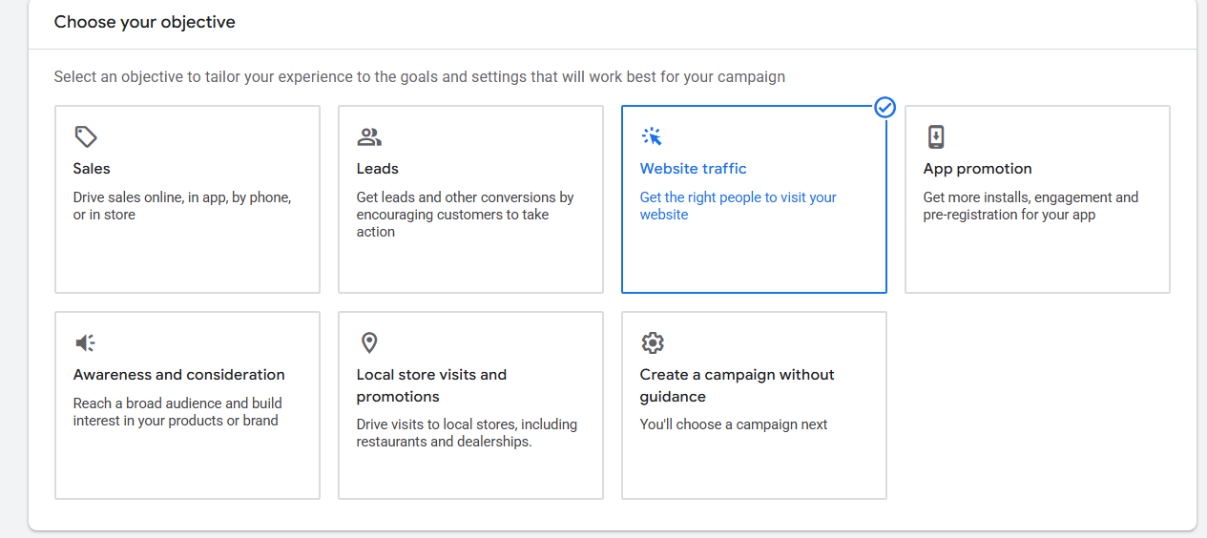
b) Budget, dates and ad schedule (if you applied)
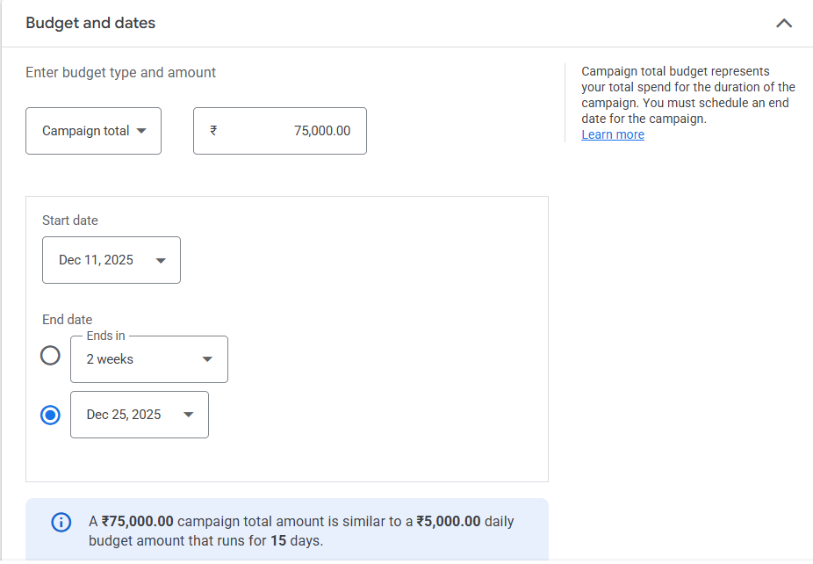
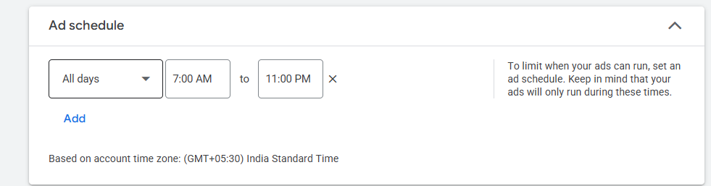
c) List of keywords research for the campaign, with their search volume and competition. (If your applied)
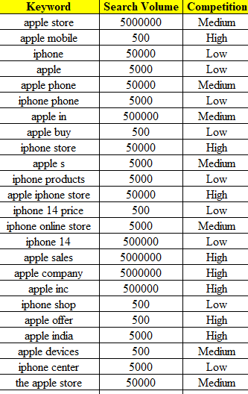
d) Target audience setup, include (Location, Demographic, Audience segments), and other targeting (device, networks, etc.)
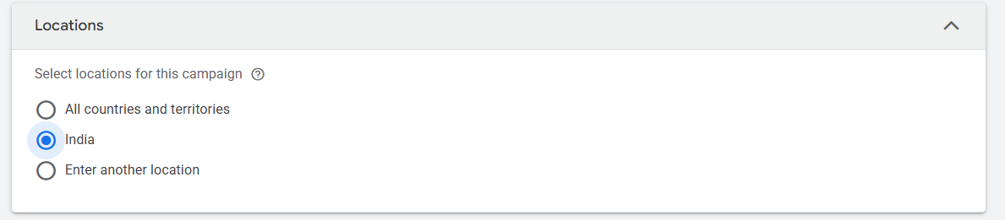
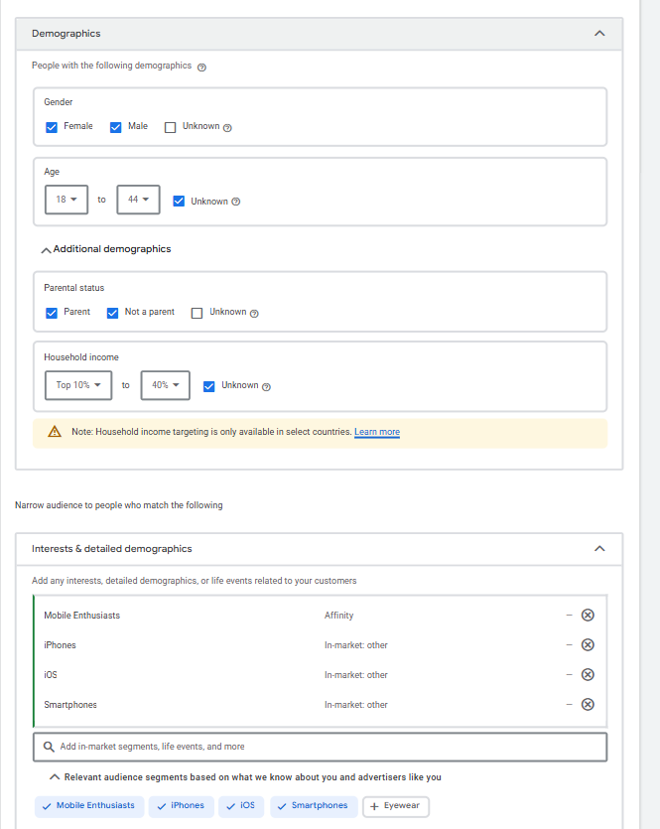
e) Screenshot of your Ad creative.
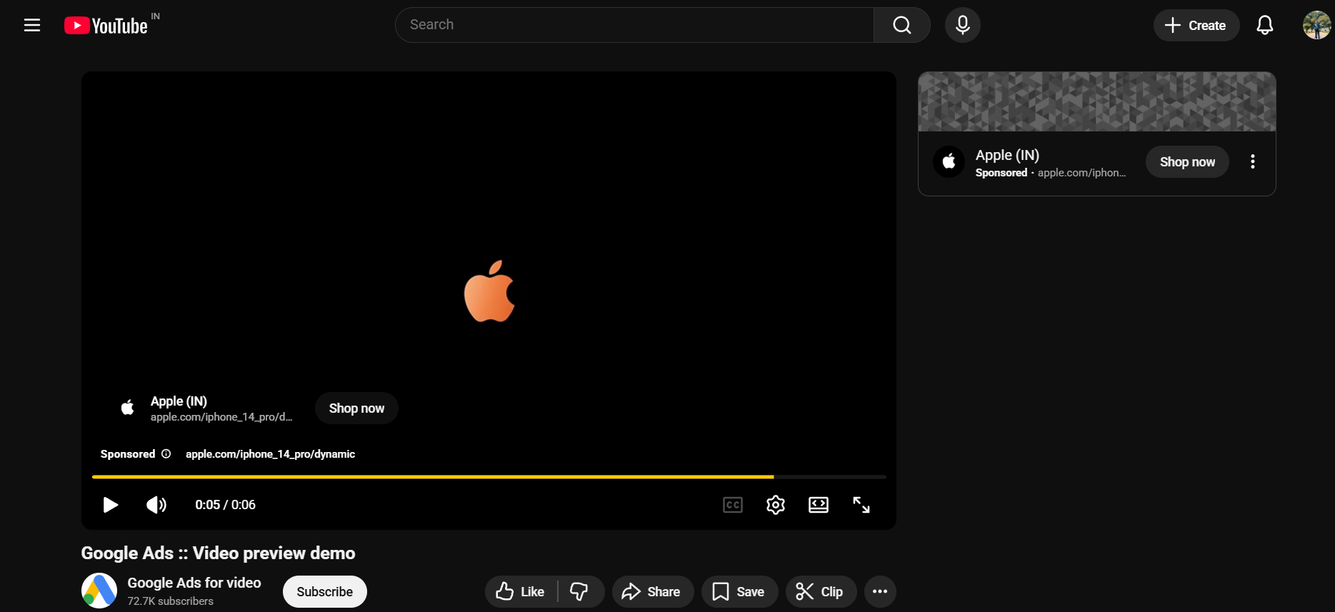
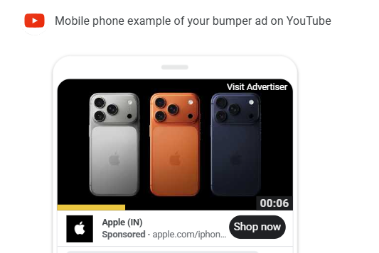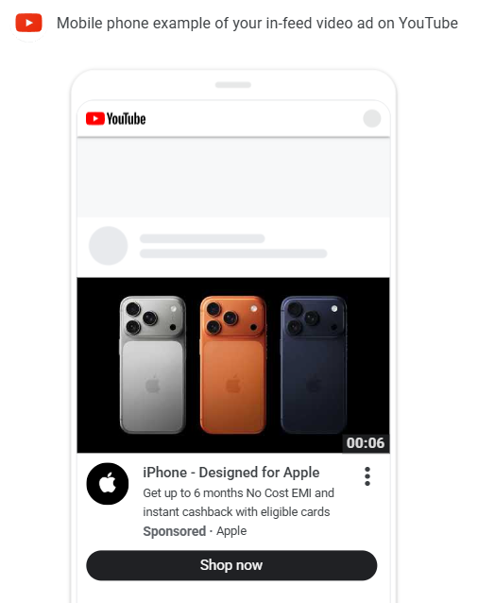

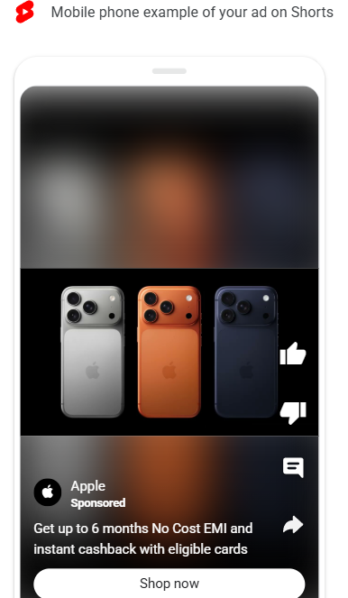
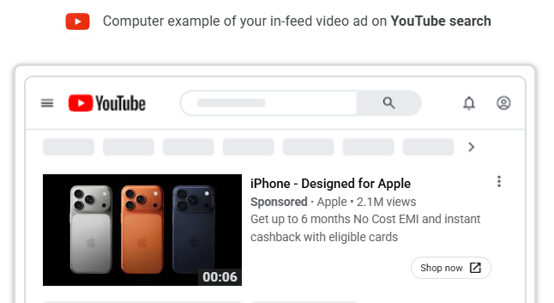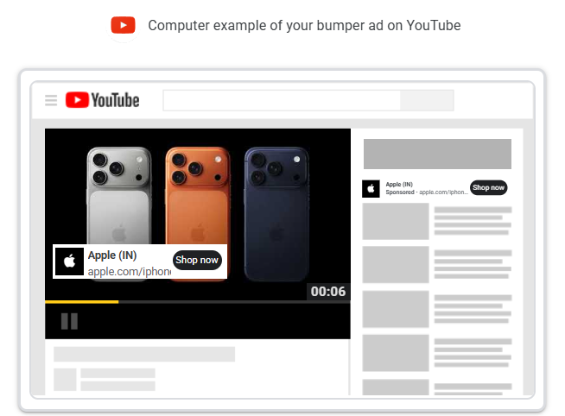
f) Estimated campaign results (from Google Ads preview/forecast)
